**Functional Testing Screenshots**

These screenshots show that your application works as intended for different features.

**1. Creating a New Product**

* ✅ Open: **Products tab**
* ✅ Action: Click **“New”**
* ✅ Fill: Product ID, Name, Unit Price, Description

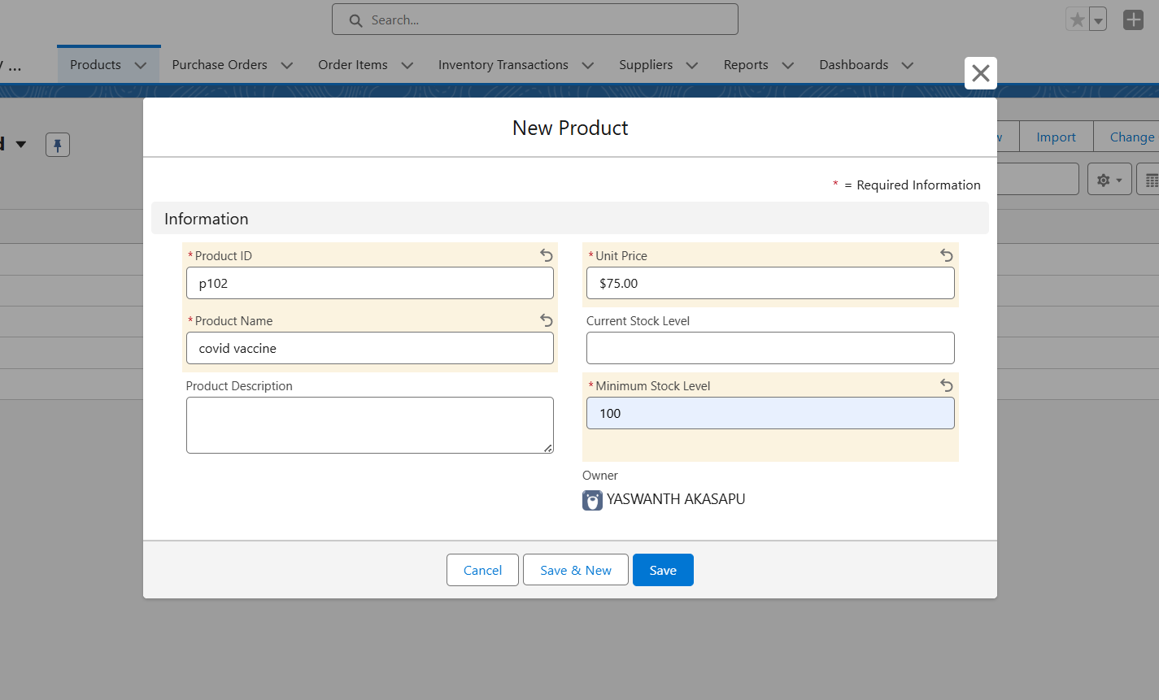

**2. Creating a New Supplier**

* ✅ Open: **Suppliers tab**
* ✅ Action: Click **“New”**
* ✅ Fill: Supplier Name, Contact, Phone

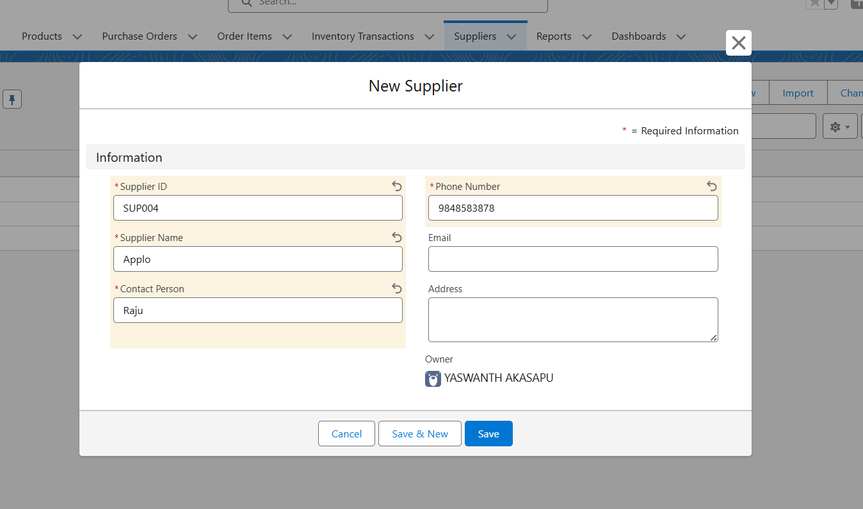

**3. Creating a Purchase Order**

* ✅ Open: **Purchase Orders tab**
* ✅ Click **“New”**
* ✅ Select Supplier, fill order date, etc.

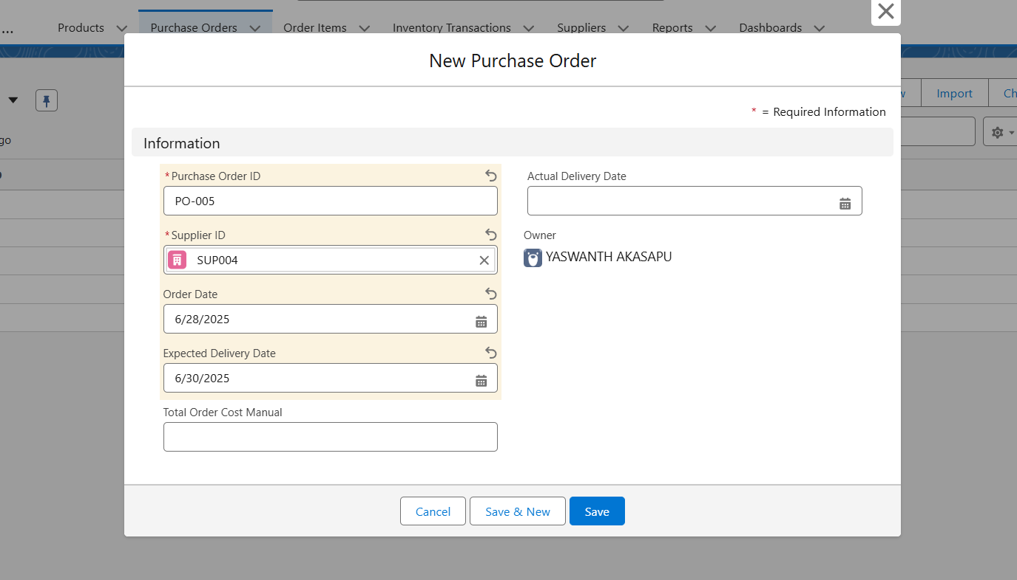

**4. Creating Order Items**

* ✅ Open: **Order Items tab**
* ✅ Click **“New”**
* ✅ Link Product & Purchase Order

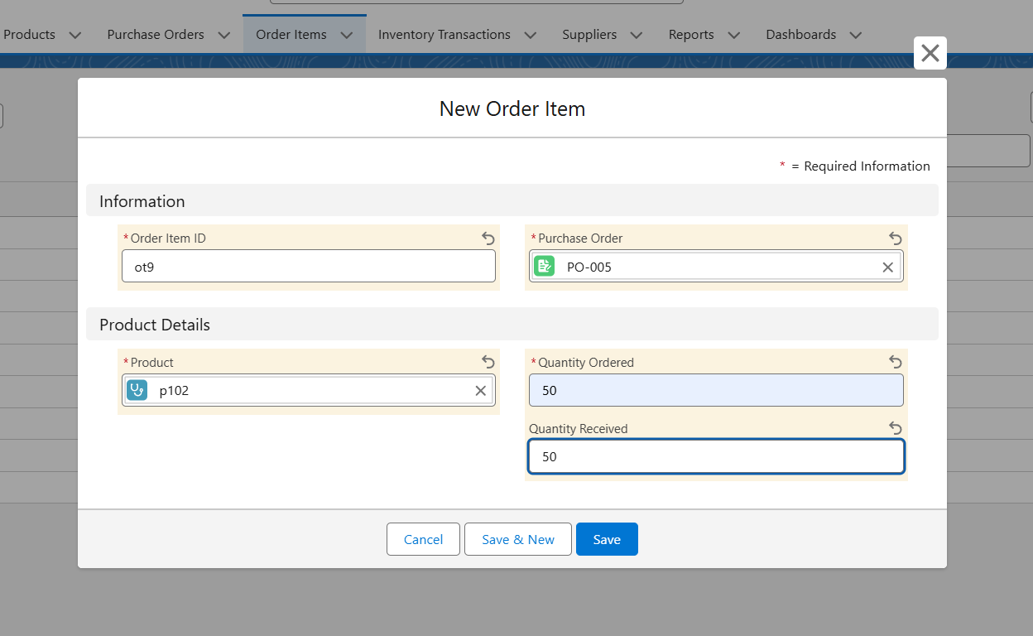

**5. Trigger Working Proof**

* **✅ Make changes in Order Item → Check Purchase Order**
* **✅ Screenshot showing updated Total Order Cost**

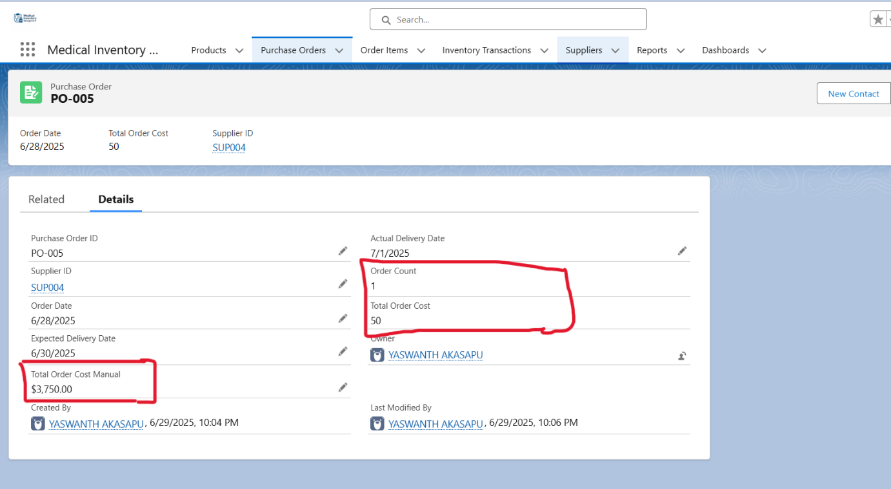

**6. Flow Functionality – Actual Delivery Date**

* ✅ Open: **Purchase Order**
* ✅ Screenshot of updated field Actual_Delivery_Date__c

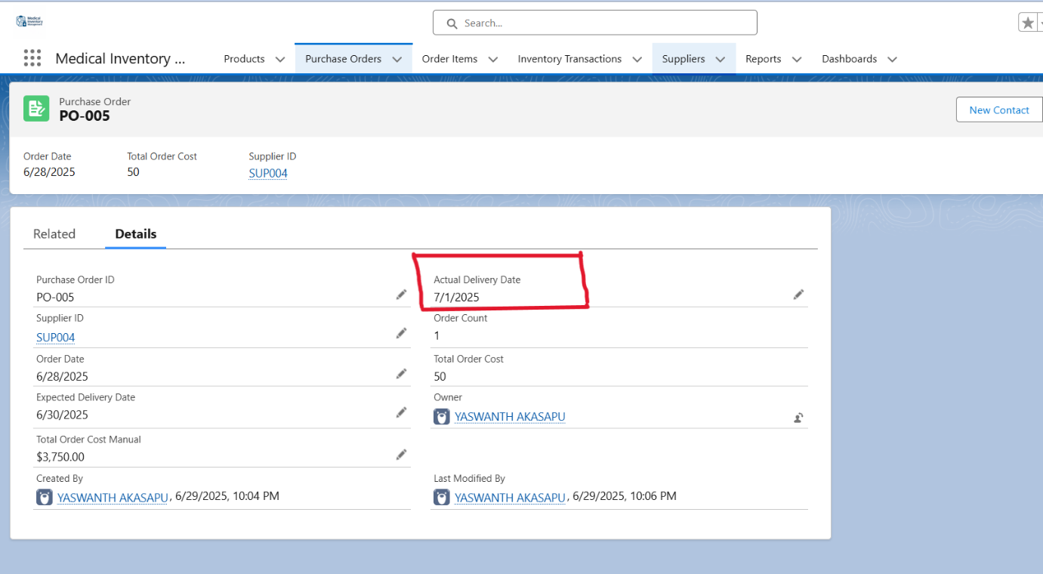

**7. Dashboard Loading Time**

* ✅ Open: **Medical Inventory Dashboard**
* ✅ Screenshot immediately as it renders charts/graphs

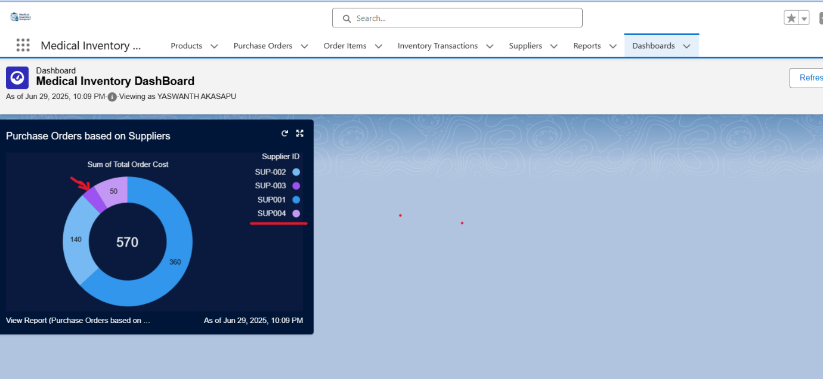

**8. Report Load Time**

* ✅ Open: **Complete Purchase Details Report**
* ✅ Screenshot with timestamp (can be manually noted)

